Stance Detection Using BiLSTM
1. Introduction to BiLSTM
BiLSTM (Bidirectional Long Short-Term Memory) is an advanced type of neural network that's particularly good at understanding sequences of data, like sentences or time series. Think of it as having two memory systems working together - one that reads the text from start to end, and another that reads it from end to start. This dual perspective helps the model better understand the context and meaning of words in relation to what comes before AND after them.
What is BiLSTM used for?
- Text classification (like detecting sentiment or stance)
- Machine translation
- Speech recognition
- Time series prediction
- Named entity recognition
In our case, we're using BiLSTM for stance detection - determining the relationship between a headline and article body, classifying them as "agree", "disagree", "discuss", or "unrelated".
2. Data Preprocessing Steps
Step 1: Data Loading and Cleaning
- Loaded the dataset from a CSV file containing headlines, article bodies, and stance labels
- Combined headlines and article bodies into a single text field
- Cleaned the text by:
  - Converting to lowercase
  - Removing special characters and numbers
  - Removing extra spaces
Step 2: Label Encoding
- Converted text labels ("agree", "disagree", "discuss", "unrelated") into numerical values (0, 1, 2, 3)
- This makes the labels understandable by the neural network
Step 3: Tokenization and Vocabulary Building
- Split text into individual words (tokens)
- Created a vocabulary of words that appear at least 3 times in the dataset
- Added special tokens: <PAD> for padding and <UNK> for unknown words
- Vocabulary size: 24,525 words
Step 4: Text to Sequences
- Converted words to numerical indices using our vocabulary
- Determined optimal sequence length using 90th percentile of text lengths
- Maximum sequence length: 541 tokens
- Padded shorter sequences with zeros to ensure uniform length
Step 5: Train-Validation-Test Split
- Split data into three sets:
  - Training set: 70% of data (for model learning)
  - Validation set: 15% of data (for tuning parameters)
  - Test set: 15% of data (for final evaluation)
Step 6: Word Embeddings
- Used pre-trained GloVe (Global Vectors for Word Representation) embeddings
- These are pre-learned word representations that capture semantic meaning
- GloVe coverage: 90.16% (meaning 90% of our vocabulary words had pre-trained embeddings)
3. Model Architecture
Attention BiLSTM Model Components:
- Embedding Layer
  - Uses pre-trained GloVe embeddings (frozen - not updated during training)
  - Converts word indices to dense vector representations
- BiLSTM Layer
  - 2-layer bidirectional LSTM with 256 hidden units
  - Dropout of 0.3 to prevent overfitting
- Attention Mechanism
  - Learns which words are most important for classification
  - Weights different parts of the text differently
- Classification Layer
  - Final dense layer with 4 output units (one for each stance class)
  - Another dropout layer for regularization
Special Features:
Focal Loss
- Used instead of standard cross-entropy loss
- Helps handle class imbalance by focusing on hard-to-classify examples
- Particularly useful when some classes have fewer examples than others
4. Training Process
Training Configuration:
- Optimizer: Adam with learning rate 0.001
- Batch size: 32 for training, 64 for validation/testing
- Early stopping: Stops training if validation loss doesn't improve for 3 consecutive epochs
Training Results:
Epoch | Train Loss | Val Loss | Train Accuracy | Val Accuracy
1 | 730.612 | 74.816 | 0.677 | 0.694
2 | 656.959 | 68.262 | 0.699 | 0.712
9 | 420.500 | 52.567 | 0.808 | 0.795
12 | 387.754 | 54.992 | 0.825 | 0.797
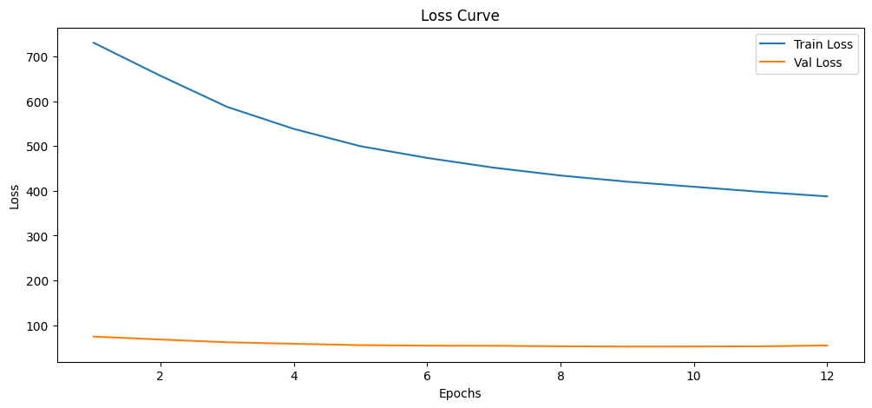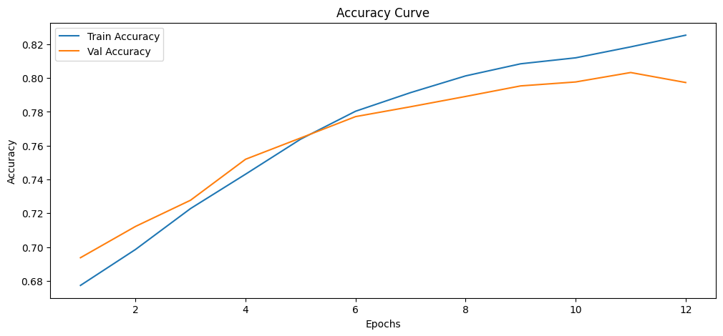
Key Observations:
- Training stopped at epoch 12 due to early stopping
- Best validation accuracy: 80.3% (epoch 11)
- Best validation loss: 52.567 (epoch 9)
- Model showed consistent improvement until epoch 11
- No significant overfitting observed (train and val accuracy close)
5, Evaluation Metrics (On Test Data)
- Overall Accuracy: 0.789
- Macro F1 Score: 0.557
- Macro AUC Score: 0.846
- EM Score: 0.789
- Top-3 Accuracy: 0.982
- Top-5 Accuracy: 1.0
Classification Report:
Class | Precision | Recall | F1-Score | Support
agree | 0.62 | 0.30 | 0.40 | 1710
disagree | 0.49 | 0.16 | 0.24 | 303
discuss | 0.87 | 0.60 | 0.71 | 1870
unrelated | 0.80 | 0.96 | 0.87 | 8114

Confusion Matrix:
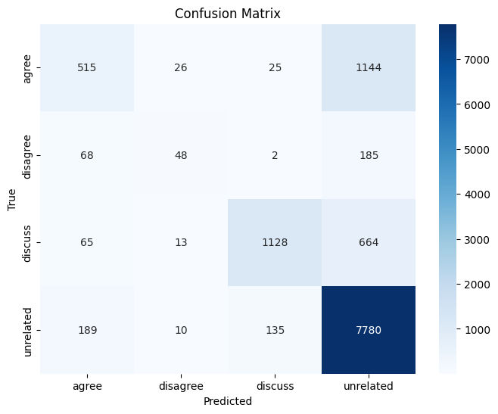
Sentiment Analysis using a TextCNN Model
Overview:
This model implements a Sentiment Analysis system for news articles and their headlines. The goal is to classify the overall sentiment of a news piece (a combination of its headline and body text) into one of three categories: negative, neutral, or positive.
The core of the system is a Convolutional Neural Network (CNN) for text classification (TextCNN), which leverages pre-trained GloVe word embeddings to understand the semantic meaning of words.
1. Data Loading & Preprocessing
- Source: Data is loaded from a CSV file containing headlines, article bodies, and sentiment labels.
- Cleaning: Text from the Headline and article Body columns is cleaned by:
  - Converting to lowercase.
  - Removing all characters except letters (Latin and Arabic-script) and spaces.
  - Collapsing multiple spaces into one.
- Combination & Label Encoding: The cleaned headline and article body are combined into a single text feature. The string sentiment labels ('negative', 'neutral', 'positive') are converted into numerical values (0, 1, 2) using a Label Encoder.
2. Text Vectorization (Tokenization & Indexing)
- Tokenization: Text is split into individual words (tokens).
- Vocabulary Building: A vocabulary is built from all unique words in the dataset, assigning a unique integer index to each word. Special tokens <PAD> (for padding) and <OOV> (Out-Of-Vocabulary) are added.
- Sequence Conversion: Sentences are converted into sequences of integers based on the vocabulary.
- Padding: All sequences are padded/truncated to a fixed length of 200 to create uniform input for the neural network.
3. Data Splitting & Batching
- The dataset is split into three parts:
  - Training set (70%)
  - Validation set (15%)
  - Test set (15%)
- The splits are stratified to maintain the original label distribution.
- PyTorch DataLoader objects are created to efficiently feed data in batches of 32 during training.
4. Using Pre-trained Embeddings (GloVe)
- Pre-trained GloVe embeddings (100-dimensional vectors from glove.6B.100d.txt) are loaded.
- An embedding matrix is created where each row corresponds to a word in the project's vocabulary, initialized with its GloVe vector if available, or zeros otherwise. This gives the model a significant head-start in understanding word meanings.
5. Model Architecture: TextCNN
The model is a classic Text Convolutional Neural Network (TextCNN class) with the following layers:
- Embedding Layer: The first layer, which is initialized with the pre-trained GloVe matrix. This layer is set to be trainable (freeze=False), allowing the embeddings to be fine-tuned for this specific task.
- Convolutional Layers: Three parallel 1D convolutional layers with different kernel sizes (3, 4, 5). This allows the model to detect patterns (features) across different phrase lengths (e.g., 3-word, 4-word, and 5-word phrases).
- Pooling & Concatenation: The output from each convolution is passed through a ReLU activation and a max-pooling layer. The results from all three branches are then concatenated into a single, long feature vector.
- Dropout & Classification: A dropout layer is applied for regularization (to prevent overfitting), and a final fully-connected (linear) layer maps the features to the 3 output classes (negative, neutral, positive).
6. Training & Evaluation
- Setup: The model is trained using the Adam Optimizer and the CrossEntropyLoss function, which is standard for multi-class classification.
- Process: The model is trained for 3 epochs. For each epoch, it processes batches from the training set, calculates loss, and updates its weights. Its performance is then evaluated on the validation set without updating weights.
- Results: After just 3 epochs, the model achieved a validation accuracy of approximately 80.2%, showing it learned effectively. The training loss decreased sharply while the validation loss was more stable, indicating good learning without severe overfitting at this early stage.

7. Visualization & Final Test
- Plots: The training and validation loss/accuracy are plotted, showing a clear learning curve.
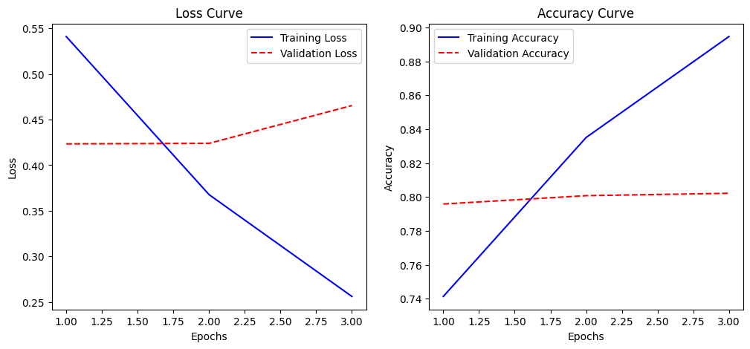
- Classification Report: A detailed report on the test set shows strong performance:
  - Overall Accuracy: 0.80
  - Exact Match (EM) Score: 0.8032
  - Precision/Recall/F1-score:
    - negative: 0.82 / 0.86 / 0.84
    - neutral: 0.83 / 0.82 / 0.83
    - positive: 0.66 / 0.65 / 0.66
  - The model performs slightly worse on the "positive" class, which is common if this class has fewer examples (as seen in the test set support: 1946 for positive vs. 6338 for neutral).
- Confusion Matrix:
